Earthlearningidea

The rock cycle in wax
蜡制岩石周期
Using a candle to demonstrate the rock cycle processes
用一根蜡烛演示岩石周期的各个环节

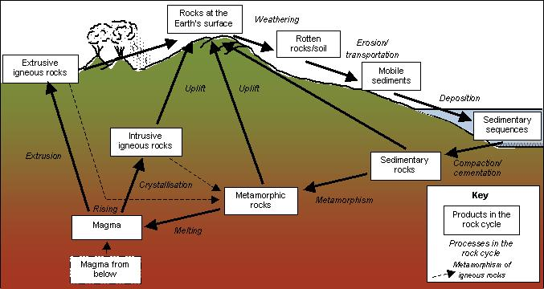

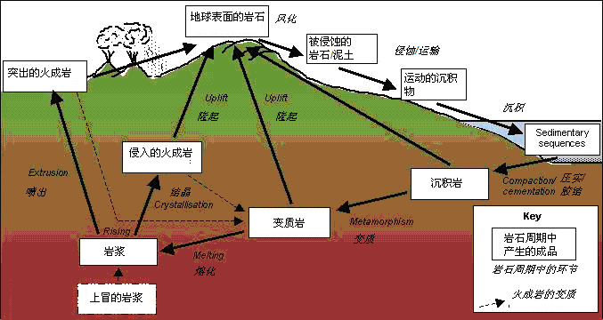

Revisiting the rock cycle
重温岩石周期
When you have taught about the rock cycle, revisit and revise it with your pupils using a candle, as follows. After each demonstration, ask: What rock cycle process does this represent? (the answers are shown in italics – more discussion is given in the ‘Back up’ notes below).
在教授岩石周期的时候，用一根蜡烛来辅助学生复习。在完成每一个演示步骤后，问学生：这代表岩石周期中的哪一个环节？（答案以斜体字表示——更多的讨论参见“备忘录”部分。
- Scrape fragments off the candle (or grate them off using a cheese grater) – erosion
- 在蜡烛上刮下一些小片的蜡块（或者用起司刷把蜡刷下来）- 侵蚀
- Allow the pieces to fall down onto a piece of paper – transportation
- 让这些蜡块掉到一张纸上 – 搬运
- The pieces build up on the piece of paper – deposition
- 小片蜡块在纸面上堆积起来 – 沉积作用
- Press down on the pile of candle fragments with the palm of your hand, saying that this would happen to the sediments at the bottom as more sediments pile up on top – compaction
用手掌从上往下挤压蜡块堆，说这就像当沉积物越堆越高时，被压在底下的沉积物所经受的一样 – 压实
- Holding your hands vertical, move them together to compress the candle fragments into a ridge of wax – metamorphism
- 保持双手互相垂直，挤压靠拢，把这些蜡块压成一个蜡脊 - 变质
- Warm the candle with a match and point out the liquid wax – melting
- 用一根火柴把蜡加热，指出液态的蜡 – 熔化
- Let the liquid wax fall onto paper and solidify – “crystallisation”
- 让液态的蜡掉到纸面上然后凝固 – 结晶
- Ask which rock cycle processes this simple model can’t demonstrate – weathering, cementation, rising, extrusion, uplift.
- 问岩石周期中的哪些部分是这个模型不能展示的 – 风化，粘固，上升，喷出，隆起。

………………………………………………………………………………………………………….

The back up 备忘录
Title: The rock cycle in wax
题目：蜡制岩石周期

Subtitle: Using a candle to demonstrate the rock cycle processes
副标题：用一根蜡烛演示岩石周期的过程

Topic: A candle is used to demonstrate several rock cycle processes, and is effective in consolidating understanding of the rock cycle at the end of a lesson.
主题：用一根蜡烛演示岩石周期中的数个环节，有效地在课堂结束时巩固对岩石周期的理解。

Age range of pupils: 11 – 16 years
学生年龄范围：11-16岁

Time needed to complete activity: 10 mins.
完成活动需要时间：10分钟

Pupil learning outcomes: Pupils can:
学生学习效果：学生可以
- describe the major rock cycle processes;
- 描述岩石周期的主要环节；
- explain how they are linked together through the rock cycle;
- 解释这些环节如何在岩石周期中互相联系；
- link simple practical demonstrations to an abstract model.
- 把简单具体的演示联系到抽象的模型。

Context:
背景
In this activity, to consolidate understanding of the abstract and potentially challenging concept of the rock cycle, different rock cycle processes are demonstrated using a candle. Further notes on the processes follow:
在这个活动里，为了巩固对抽象难懂的岩石周期的理解，我们用一根蜡烛来演示了岩石周期中的不同环节。以下是进一步的解释。
- weathering is the break up or break down of rocks in place (in situ) in which no solid material is moved away, by chemical, physical or biological activity - it cannot be demonstrated using the candle;
- 风化 是岩石在原位置被化学、物理或者生物作用分解的过程，在这过程中坚固的材料不被带走 ——蜡烛不能演示这个过程；
- erosion is the removal of material by the action of gravity, water, wind or ice – the candle demonstrates removal of wax fragments by physical activity (abrasion) and their falling away through gravity;
- 侵蚀 是材料被重力，水，风或冰的运动带走的过程——蜡烛演示了蜡因物理运动（刮）而脱离和因重力作用而下落的过程。
- transportation is the movement of fragments by gravity, water, wind or ice until they are
deposited – the candle demonstration shows transportation downwards by gravity;
- 运输是材料被重力、水、风或者冰搬到他处直到沉积的运动——蜡烛演示了重力产生的向下的搬运作用。
- deposition is the laying down of material – shown here by the build up of wax fragments;
- 沉积作用 是材料被放下、堆积——在这里通过蜡块的堆积演示出来；
- compaction is the compression of sediments by the weight of the deposited material above; compression alone can cause muds to become mudstones – it is shown here using the palm of the hand;
- 压实是沉积的材料受上层沉积物的重量所压缩。压实作用可以使泥浆变成泥岩——这里通过手掌来演示。
- cementation is the growth of small crystals of natural cement in the pore spaces of the sediment grains, cementing them together; cementation can cause sands to become sandstones, calcium carbonate fragments to become limestones, etc. – it cannot be shown using the candle demonstration;
- 胶结是沉积物颗粒间的气孔里产生的自然水泥小块晶体把沉积物粘结在一起；胶结作用可以使沙变成沙岩，碳酸钙颗粒变成石灰石，等等。——不能用蜡烛演示。
- metamorphism is the change of sedimentary rocks (or igneous rocks) into metamorphic rocks by heat and increased pressure during mountain building episodes – it usually involves lateral compression, demonstrated here by making a ridge of wax in which the wax fragments are aligned at right angles to the pressure (as in metamorphism) and the ‘rock’ becomes less porous and ‘harder’ (Note: small scale metamorphism mainly by heat occurs near hot igneous bodies – this type of metamorphism cannot be shown by the candle);
- 变质是沉积岩在山脉形成过程中因受热或压力增加而变成变质岩——通常受到侧压，在这里通过制作蜡脊来演示，过程中蜡块受到直角方向的压力（就像在变质过程中一样），然后‘岩石’变得更加少孔和‘坚硬’（注意：小规模的因受热产生的变质过程主要发生在热熔岩物体附近——这种变质作用不能用蜡烛演示）
- melting of a rock to magma (through either partial or total melting) happens when rocks become hot enough – shown here by heating the wax with a match;
- 岩石熔化形成岩浆（完全熔化或者部分熔化）发生在岩石变得足够热的时候——这里通过用火柴加热使蜡熔化来演示；
- rising of hot magma occurs because it is less dense than the surrounding rock – not shown by the candle;
- 热熔岩的上升是因为它们的密度比周围岩石的密度要小——蜡烛不能演示；
- crystallisation occurs when a magma cools and solidifies – shown by the wax solidifying here, although candle wax doesn’t strictly crystallise, it just solidifies;
- 结晶发生在岩浆冷却凝结的时候——通过蜡的凝结来演示，虽然蜡不会结晶，只能凝结。
- extrusion occurs when magma reaches the surface, either as lava flows or explosively as bombs and ash;
- 喷出发生在岩浆达到表面，无论是熔岩流出还是火山喷发。
- uplift is the pushing upward of great masses of rock, usually during mountain-building episodes; as the overlying rock is eroded away, deeper and deeper layers are exposed.
- 隆起是大体积的岩石被抬高，通常发生在山脉形成的过程；当叠在上层的岩石被侵蚀，越来越深层的岩石被展示出来。

Following up the activity:
后续活动：
Ask pupils how some of the rock cycle processes that cannot be demonstrated using a candle, could be demonstrated in other ways. Some can be shown by the Earthlearningidea ‘Wax volcano’. Also ask pupils what energy sources drive the rock cycle processes – most of the external processes are driven by solar energy, largely through the water cycle, whereas most internal processes are driven by the Earth’s energy (largely from radioactive decay) through plate tectonic processes.
问学生可以用什么方式去演示那些不能用蜡烛来演示的环节。一些可以在Earthlearningidea的‘蜡制火山’那里看到。也可以问学生什么类型的能量促使这些岩石周期过程的发生——多数的外部作用过程是太阳能推动的，主要通过水循环，而多数的内部作用是板块运动过程中释放的地球能量（主要通过放射性衰变）推动的。

Underlying principles:
背后的原理：
- gravitational effects causing erosion, transportation and deposition;
- 重力作用引起侵蚀，运输和分解；
- lateral forces causing compression and changing of a material;
- 侧压力引起材料的压缩和形变；
- change of state by melting and solidifying.
- 熔化和凝固改变物质的状态。

Thinking skill development:
思维技能发展：
Picturing the rock cycle is a constructional activity and applying understanding of the rock cycle processes to a series of simple demonstrations involves bridging. Cognitive conflict emerges when pupils are asked which rock cycle processes the candle cannot demonstrate.
想象岩石周期是一个构建活动，而把对岩石周期的理解应用到一系列简单的演示活动上是一种联系活动。认识冲突发生在学生被问到哪些岩石周期环节不能被演示的时候。

Resource list:
资源列表：
- Candle
- 蜡烛
- knife or other metal object to scrape off wax fragments (or a cheese grater)
- 小刀或者其它金属物体（或者起司刷），用来把蜡片刮下来
- piece of paper
- 纸
- matches
- 火柴

Useful links: See the Earth Science Education Unit’s ‘The dynamic rock cycle’ workshop booklet at:
http://www.earthscienceeducation.com/workshops/worksheets/dynamic_rock_cycle.PDF for a range of other simple ways to demonstrate rock cycle processes.
有用链接：查看地球科学教育单元的‘动态岩石周期’工坊的小册子：http://www.earthscienceeducation.com/workshops/worksheets/dynamic_rock_cycle.其它一系列岩石周期的演示的PDF。

Source: Activity devised by Chris King of the Earthlearningidea team.
来源: 活动由来自Earthlearningidea团队的Chris King设计。

注：此文档由Victor（Pan Weixiang）编译， 邵延秀修改完成
 Earthlearningidea team Earthlearningidea 致力于以最小的开支，每周为在校的地学教师提供一个教学方案，以及在线讨论，发展为一个全球支持的网络平台。‘Earthlearningidea’没有基金支持，主要为志愿者提供支持。
我们对将本方案用于课堂和实验室目的，不保留任何版权。教学方案中所使用的其他出版商的资料的版权，归原出版商所有。任何机构想使用这些资料需要联系Earthlearningidea团队。
我们也希望教学方案中一些资料的版权持有者允许使用那些材料，如果侵犯了您的权利，请与我们联系，我们将会修改和更新内容。
如果您在阅读这些文档的时候，遇到什么困难，请联系Earthlearningidea团队获得支持。Email：info@earthlearningidea.com。
中文版版权归GeoIdea团队所有，如有需要，请登陆www.geoidea.org与我们联系。



